**Sexual dimorphic blue bands are intra-sexual aposematic signal in the male pond damselfly**

Md Kawsar Khan1*, Marie E. Herberstein1

1. Department of Biological Science, Macquarie University, NSW-2109, Australia

**Author of correspondence:**

Md Kawsar Khan

Department of Biological Science

Macquarie University, Sydney

NSW-2109, Australia

Email: [Kawsar.khan@mq.edu.au](mailto:Kawsar.khan@mq.edu.au)

Phone: +612-9850-6279

Key words: warning signal, sexual conflict, ornamental colouration, visual modelling

Abstract

1. Sexually dimorphic traits in males are thought to evolve via female preference. However, in species without overt male displays or female mate choice, dimorphic colouration may function as a warning signal to conspecific males thereby avoiding costly harassment. We tested this idea in the damselfly *Xanthagrion erythroneurum* where males, but not females carry conspicuous blue bands on the tip of the abdomen.
2. We abolished male blue bands by painting black over blue and measured the female preferences between the manipulated and the control males. We did not find any difference in mating success between the control and manipulated male thereby rejected the female preference hypothesis for the function of blue bands in this damselfly.
3. To test whether the blue bands function as a warning signal, we manipulated the females by painting male-like blue bands on their abdominal segments and measured the male reaction to those females relative to control females. Females with artificial blue bands on the terminal abdomen were mated with less frequently than control females. However, when we painted blue bands on the anterior abdominal segments the males did not discriminate between control and painted females.
4. We conclude that the blue bands in male damselflies function as a position-specific aposematic signal towards other males to avoid intra-sexual harassment.

Introduction:

According to sexual selection theory, conspicuous male colouration in animals can evolve if they improve attractiveness to females or increase success in male-male competition or both (Darwin, 1888). One striking example of conspicuous male colouration is the sexual dimorphic colouration, also known as ornamental colouration. In such cases, males exhibit their ornamental colouration during courtship display and females prefer mating with more conspicuous males. The sexual dimorphic male colouration is often associated with male qualities such as better physiological conditions (body mass (Contreras-Garduño, Buzatto, Serrano-Meneses, Nájera-Cordero, & Córdoba-Aguilar, 2008), body size (Serrano-Meneses, Córdoba-Aguilar, Méndez, Layen, & Székely, 2007), immunity(Córdoba-Aguilar, 2002), and sperm quality (Fukuda & Karino, 2014)), better territory defending capabilities (Córdoba-Aguilar, 2002) and higher social status (Bergman, Ho, & Beehner, 2009). On the other hand, in many species where males do not exhibit courtship displays, male-limited dimorphic colouration can still evolve as an intra-sexual signal irrespective of female preferences. Conspicuous dimorphic male colouration can display male fitness to avoid the cost of unnecessary fights (Olsson, 1994) or unprofitability as a mate-partner to avoid unwanted mating encounter from other males (Beatty, Andrés, & Sherratt, 2015).

Sexual dimorphic blue bands are commonly found in many damselflies of Coenagrionidae family. In these damselflies, males neither maintain territories, nor do they perform courtship displays (Corbet, 1999). The mate searching males hover around the breeding ponds looking for a mating partner, and the scenario resembles a scramble competition among males. After encountering a female, the male approach from behind and grasps the female from above to mate. As a consequences of that the females cannot see the colour of an approaching male. Moreover, the males can coerce a female to mate even when it is unwilling. As a consequences of that, the females do not have a choice over whether or not they mate or with whom, making inter-sexual selection an unlikely mechanism to drive male-limited colour dimorphism. Sherratt and Forbes (2001) proposed that conspicuous male colouration in these damselflies is not a signal to females, rather it is a warning signal to other males to avoid costly mating harassment (Sherrat & Forbes, 2001). In a scramble mating competition erroneous male-male mating occurrence is not uncommon (). In this circumstance, male-limited conspicuous colouration can evolve to display their unprofitability as a mate to conspecific males.

Fincke (1997), however, argued that, females can show mating unwillingness and avoid tandem formation by hiding themselves, by flying away, by death feigning, by abdomen curling and by wing raise signal (Fincke, 1997). Moreover, even after a tandem formation a male needs female’s cooperation for bending her abdomen to from wheel to receive the sperm. Female can show resistance in this stage and can delayed wheel formation and even dissociate from the wheel. In the presence of such strong female choice, female would be able to reject unwanted males. In this circumstance, sexual dimorphic ornamental colouration can evolve from preferences. Although intriguing female preferences for male colouration is yet to be tested in damselfly.

In *Xanthagrion erythroneurum* damselfly, adult males have two blue bands on the dorsum of abdominal segments 8 and 9, (S8 and S9) whereas the female does not have this bands (Figure 1a, 1b). We aim to determine the function of the male-limited blue bands in this damselfly. We aim to experimentally test both the sexual selection hypothesis and the antiharassment aposematic hypothesis. If the male specific blue bands evolved through female preferences, we predicted that mating success of a male with blue bands will be higher than the success of a male without them. On the other hand, if blue bands function as an intrasexual aposematic signal, the presence of the blue bands will antagonize the mating desire of an approaching male. The best way to experimentally validate the hypothesis is to paint the blue bands in female’s abdomen and observe the mating decision of the approaching males. We predict that the presence of the blue bands will repel males and thus females bearing blue bands will be avoided, even though males are able to recognize females based on other female cues.

Materials and Methods

Study species

The Red and blue damselfly, *X. erythoneurum*,is a medium size damselfly (19-21 mm) of Coenagrionidae family (Zygoptera: Odonata). This species is widely distributed across all Australian states and commonly found in ponds, marshes and dams (Theischinger and Hawking). The adult male can be easily distinguished from the other Coenagrionidae species by the red face, red thorax, first two and half red abdominal segments, and by the blue bands in abdominal segments eight and nine. In the Sydney region, the species can be seen in flight from September to March and their reproductive season lasts throughout the whole period (ref).

We collected adult male and female X. erythroneurum damselflies using an insect sweeping net from the lake situated in the North Ryde campus of Macquarie University, NSW, Australia. No permission were required to collect the damselflies because this species is not protected in Australia and studies were not conducted inside any national park or protected area.

Reflectance spectra

We measured the reflectance spectra of the abdominal blue bands of the males from the segments S8 and S9 and the black colouration of the female in the same segments with a Jazz Ocean optics spectrophotometer (Ocean optics, USA). We set the spectrophotometer at an integration time of 20 milliseconds with an average of five successive scans. We used a PX-2 pulse xenon light source and took the measurements relative to a white standard WS-1. We immobilized the damselflies by restraining in a refrigerator at 40C for five minutes before taking the spectra. We focused the light source of the spectrophotometer perpendicular to the cuticular surface of the damselflies and took spectra from a uniform distance of 2mm. We used a black velvet cloth to block light between the probe and the specimen. We took spectra of the plant leaves from the pond site where the damselflies usually perch to quantify the background spectrum. We measured reflectance spectra of the damselflies and background leaves between 300nm to 700nm averaged from three measurements.

Discriminability

We used a discriminability index (D) to estimate the chromatic discriminability (Ds) of damselfly abdominal colouration (blue in male and black in female) against the natural background based on the index proposed by Hastad et al. (Hastad, Victorsson, & Ödeen, 2005):

$Ds=$ $\frac{\overline{{ΔS}_{D}}- \overline{{ΔS}_{B}}}{\sqrt{{ΔS}_{D}}}$

Where $\overline{{ΔS}_{D}}$ is the average of the chromatic distance of each damselfly spectrum to the measured background spectra and $\overline{{ΔS}_{B}}$ is the average chromatic distance between each background leaf sample. We used a similar rationale for calculating achromatic discriminability (DL) based on the quantum catches of the green photoreceptor since bees and other insects use this photoreceptor to detect achromatic contrast (Giurfa, Vorobyev, Kevan, & Menzel, 1996). The discriminability values (chromatic and achromatic) indicate whether the blue bands of males or black abdomens of females are detectable against the natural background ─ a value above zero indicates the signal is visible. Because it is unclear if this species has a tri- or a tetrachromatic visual system, we calculated the discriminability for both and applied unpaired t-tests to compare the chromatic and achromatic discriminability between the sexes.

Female preference experiments

We manipulated the colour of the damselflies using non-toxic colour paint (Tim and Tess poster paint). We used black colour to hide the blue bands of the male abdomen. For the control males we applied the black colour in the dorsum of abdominal segments S7. We kept one manipulated and one control male with two females in an insect mating cage (58cm × 32cm × 34cm). We placed the cage close a natural lake, in the natural sunlight and observed their sexual interaction from a distance of approximate one meter. We calculated the number of tandem and wheel formation of control and manipulated males. In case tandem did not last until wheel, we calculated the duration of tandem before it dissociate. We also recorded the time taken to reach from tandem to wheel formation and the duration of wheel. A successful trial was counted when a male form a tandem with a female. If tandem did not occur within 30 minutes we record it as an unsuccessful trial. The experiment were continued until we reach sixty successful trial.

Male choice experiments

We manipulated female colour using non-toxic colour paint (Tim and Tess poster paint). We painted female with two blue bands matching the colour and brightness of the males (Figure 1a). In two separate experiments, we varied the position of the bands ─ in the first, the blue bands were applied in the same position as on the male (segments S8 and S9) but in the second experiment we painted the blue bands on segment S4. To control for the paint, we applied black paint over the natural black patches on the control females.

We placed four damselflies (two males, one control female and one manipulated female) into an insect mating cage (58cm × 32cm × 34cm) at the edge of a pond and observed their behavioral interactions. We terminated a trial if a male successfully formed a tandem with the female or after 20 minutes if no tandem occurred. For each experiment, we performed 40 successful trials between 10 am to 4 pm (November 2016 to January 2017) when mating usually occurs in the field. We applied chi-square test to compare the frequency of tandem pairs in each experiment.

Results

Damselfly spectra

The reflectance spectra of the male blue abdominal bands peaked between 450 and 481 nm while the female abdominal segments did not show any peaks but a gradual increase with increasing wavelengths (Figure 1c). Like males, manipulated females bands also showed reflectance peaks in this region (471-472nm) (Figure 1c).

Discriminability

Both male abdominal blue bands and female abdominal colouration were chromatically and achromatically discriminable in the trichromatic damselfly visual system against the natural background (Figure 1d and Figure 1e). The chromatic discriminability of the male blue bands was significantly (p < 0.001) higher than female (Figure 1d). However, no significant discriminability was found between the sexes achromatically (figure 1e). In case of a tetrachromatic visual system, both sexes are discriminable against their background ─ males are chromatically more discriminable (p < 0.001) while achromatic contrasts are significantly higher in female (p < 0.001) (Supplementary figure 1 (a, b)).

Female preference

The natural and manipulated males do not differ significantly in terms of tandem and wheel formation. Similarly, there is no significant difference in tandem duration, the time required from tandem to wheel formation and wheel duration between control males and manipulated males.

Male choice assays

When females carried blue bands on abdominal segments S8 and S9 (similar to male colouration) males significantly (χ2 = 4.900, df= 1, p < 0.05) preferred control females over manipulated females (Figure 2a). However, when the females carried the blue bands on abdominal segment S4, the males formed tandems at the same rate with manipulated and control females (χ2 = 0.400, df= 1, p = 0.527) (Figure 2b). We did not observe any male-male tandem formation.

Discussion

We found that the damselfly visual system can discriminate the sexual dimorphic male blue bands from female abdominal colouration. We manipulated the male blue bands and observed the female preference for mating partner between the altered and control males. If the male blue bands are sexually selected ornamental colouration then the male with the blue bands will have sexual success more than the males without blue bands. Our results, however, shows that there is no significant difference in the number of tandems between the control and manipulated males. As males approach from above the female during tandem formation, the females cannot immediately see male colouration and cannot reject an approaching male on the basis of its colouration. One might argue that in a cage experiment a female cannot fly away from an approaching male even if it wants to, and the outcome can be due to restrictive movement of the females. A female can still reject a male and dissociate from the tandem, or can delay the wheel formation. We did not, however, find any difference in tandem duration, numbers of wheel formation and the duration of wheel formation between the control and manipulated males. From our knowledge, our study provides the first experimental evidence showing in damselflies the female does not have preference for dimorphic colouration in males. As a consequence of that, male-limited dimorphic colouration is unlikely to evolve through female preferences.

We also found that when females carried blue abdominal bands in the same position as males, they were less attractive than control females or females that carried blue bands elsewhere on the abdomen. There are several possible interpretations for our observations: males failed to recognize manipulated females as potential mates or the blue bands act as a warning signal to males. We argue for the latter interpretation as males had sufficient cues available to identify females. Odonates use tactile and visual cues for mate recognition (Winfrey & Fincke, 2017). The female black abdomen is the most important cue for mate recognition (Gorb, 1998). However, males also use body size (Pezalla, 1979), abdomen shape (Gorb, 1998; Ubukata, 1983), flight pattern (Ubukata, 1983), female display (S. Gorb, 1992; Utzeri, 1988), thorax colouration and pattern (Miller & Fincke, 1999; Xu, Cerreta, Schultz, & Fincke, 2014) and chemical cues (Frati, Piersanti, Conti, Rebora, & Salerno, 2015) for mate recognition. Moreover, Gorb (1998) showed that males can even recognize a female based on part of their whole or by the presence of any female part (thorax, head) (Gorb, 1998). Hence, we argue that the males in our study can still identify the manipulated females as a conspecific female based on her overall phenotype. However, the presence of the blue bands on the female’s abdomen repelled males and may thus function as a warning signal, possibly indicating an unprofitable mating partner.

To define the conspicuous colouration that displays unprofitability Poulton (1890) used the term “aposematism” (Poulton, 1890). Later on, “aposematism” was typically used in the context of predator-prey interaction where bright, vivid colouration of a prey signals their unpalatability to predators. However, aposematic signals are not restricted to interspecific communication, neither are the functions limited to predation avoidance. For example, in *Battus phileno* butterflies, the colour pattern of the larva is an intraspecific aposematic signal to repel conspecific females from ovipositing on the same leaves, thereby reducing intraspecific competition (Papaj & Newsom, 2005). In damselflies Sherratt and Forbes applied the concept of aposematism in a sexual context and coined the term ‘antisexual aposematism’ to explain the function of conspicuous colouration to avoid unwanted sexual harassment. The hypothesis was later supported in the *Nehalennia irene* damselfly, where abdominal blue colouration on males repelled conspecific males (Beatty et al., 2015). Our present finding further solidify this hypothesis by showing that the males avoid mating with females bearing the warning signal even after knowing them as potential mate based on other mate recognition cue.

Our results showed that the spatial location of the aposematic bands is crucial for their function. The bands were only effective on the terminal abdominal segment. This make sense considering the mating biology of damselflies where males approach from behind and grab females from the top to form a tandem (Corbet, 1999). Hence, an aposematic signal will function best if presented on the distal dorsal body side. Moreover, male damselflies often raise their tail in a threat display towards conspecific males (Utzeri, 1988). Therefore, the aposematic signaling in male damselfly depends on spatial location and is only effective when presented at the tip of the abdomen.

In *Xanthagrion erythroneurum* damselfly, warning signal comprises two blue bands separated by black abdominal coluration. The blue and black adjacency generates high internal contrast. Further, blue colour of damselflies generates high chromatic and achromatic contrast against a natural green background (Schultz, Anderson, & Symes, 2008). Aposematic signals are most effective when they generate high internal contrast and against the background (Stevens & Ruxton, 2012). Moreover, high colour contrast signals enhance speed and stability of avoidance learning and reduce recognition errors (Gamberale-Stille, 2001).

Aposematism benefits both the signaler and the receiver. In *X. erythroneurum*, the warning signal helps males to avoid male-male tandem formation, which is costly in terms of time and energy for both males. Abdominal blue bands in males are commonly found in many damselfly species [Peer observation, see also 10, 13] and thus our findings raise the tantalizing question whether blue abdominal bands function as an aposematic signal across many odonatan taxa.

References:

Figure 1: Photograph of a male and (b) a female *X. erythroneurum* (c) Aggregated reflectance spectra (mean ± SD) of the males blue bands (N= 20, red line), females abdominal colouration (N = 14, green line), painted blue bands on the manipulated females (N= 8, blue line) and background plant leaves (N= 31, purple line) (d) Chromatic discriminability (Ds) and (e) Achromatic discriminability (DL) of male and female abdominal (S8-S9) colouration in the trichromatic damselfly visual system.

Figure 2: (a) Number of tandems formed by the control and the manipulated males (b) Number of wheels formed by the control and the manipulated males (c) Duration in tandem formation between the control males and the manipulated males (d) Time required to form wheel from the tandem between the control males and the manipulated males (e) Duration in wheel formation between the control males and the manipulated males. (ns= not significant).

Figure 3:

(a) The number of control females and S8 and S9 manipulated females (blue bands on segments S8 and S9) and (b) the number of control females and S4 manipulated females (blue bands on segment S4) recorded in mating pairs during the mate choice experiment (n = 40, * p<0.05).

Figure 1:

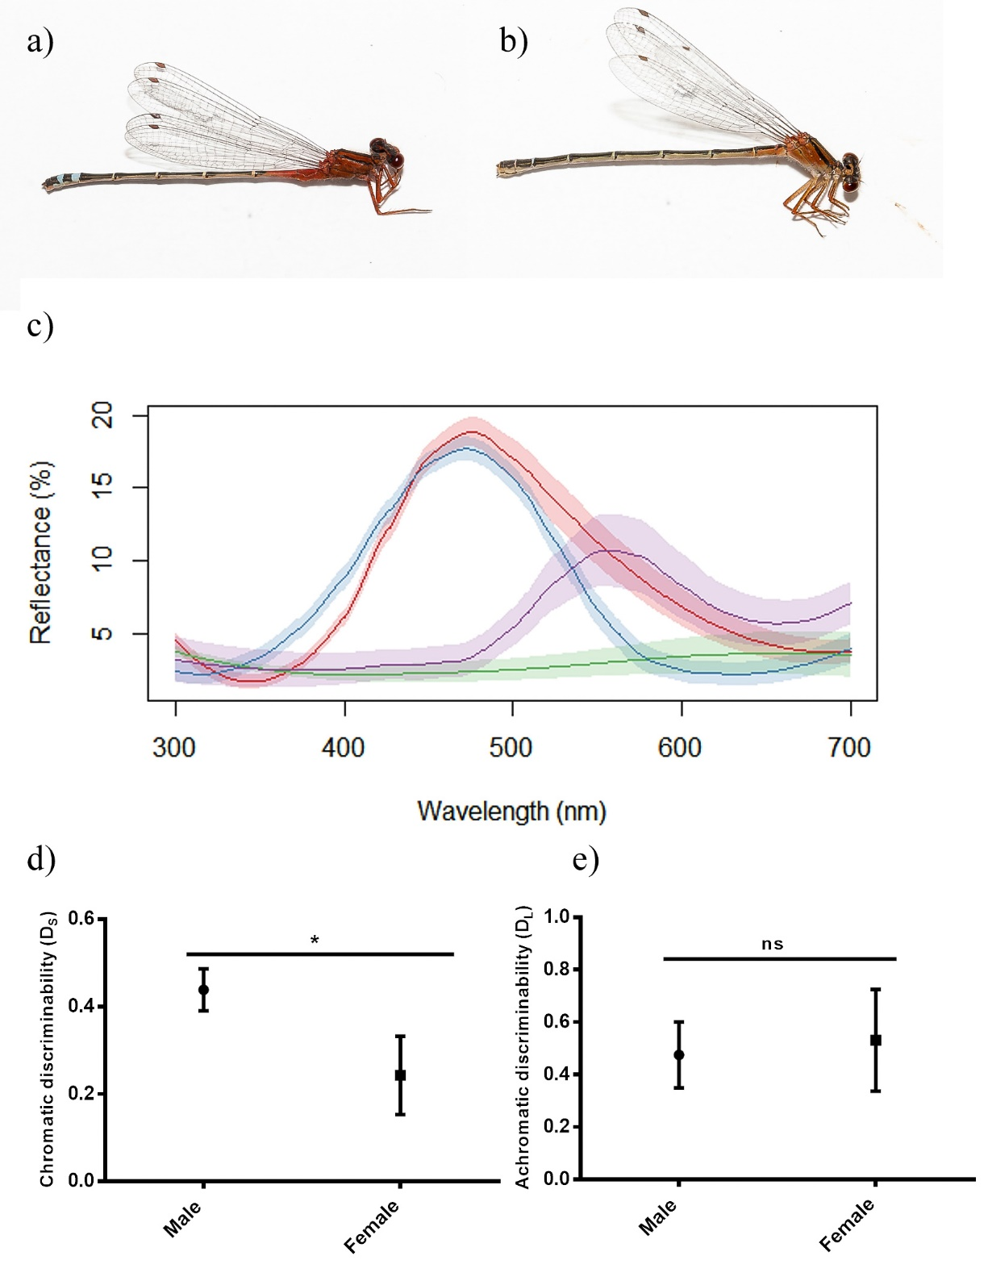

Figure 2:

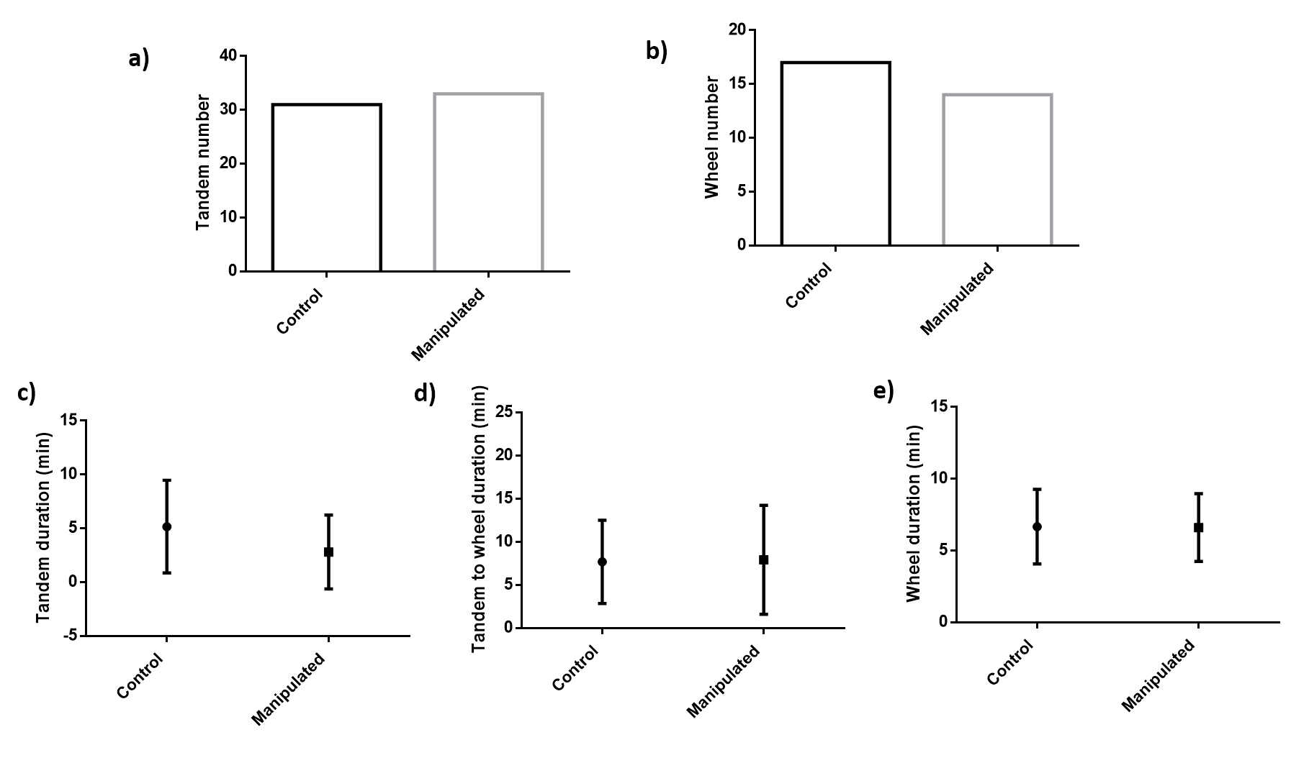

Figure 3:

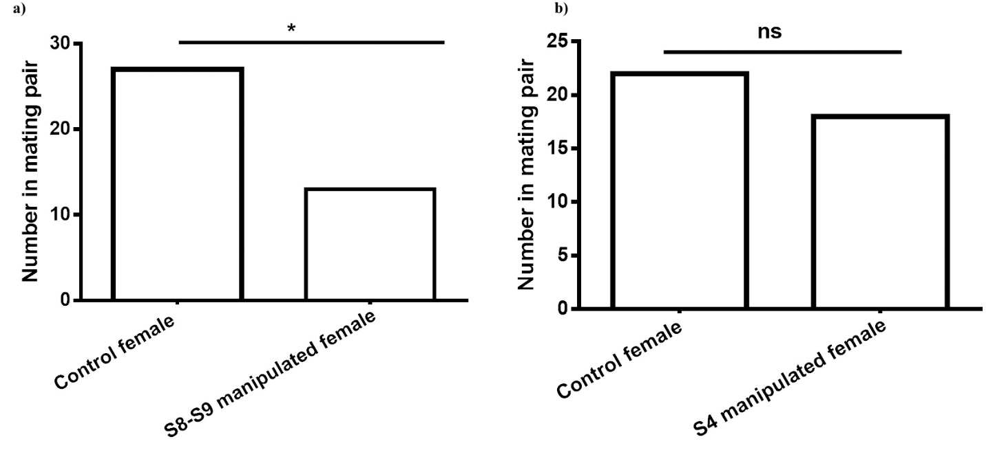

**References:**

Beatty, C. D., Andrés, J. A., & Sherratt, T. N. (2015). Conspicuous Coloration in Males of the Damselfly Nehalennia irene (Zygoptera: Coenagrionidae): Do Males Signal Their Unprofitability to Other Males? *PLOS ONE*, *10*(11), e0142684. https://doi.org/10.1371/journal.pone.0142684

Bergman, T. J., Ho, L., & Beehner, J. C. (2009). Chest Color and Social Status in Male Geladas (<Emphasis Type="Italic">Theropithecus gelada</Emphasis>). *International Journal of Primatology*, *30*(6), 791–806. https://doi.org/10.1007/s10764-009-9374-x

Contreras-Garduño, J., Buzatto, B. A., Serrano-Meneses, M. A., Nájera-Cordero, K., & Córdoba-Aguilar, A. (2008). The size of the red wing spot of the American rubyspot as a heightened condition-dependent ornament. *Behavioral Ecology*, *19*(4), 724–732. https://doi.org/10.1093/beheco/arn026

Corbet, P. S. (1999). *Dragonflies: Behaviour and Ecology of Odonata*. New York: Cornell University Press.

Córdoba-Aguilar, A. (2002). Wing pigmentation in territorial male damselflies, Calopteryx haemorrhoidalis: a possible relation to sexual selection. *Animal Behaviour*, *63*(4), 759–766. https://doi.org/10.1006/anbe.2001.1974

Darwin, C. (1888). *The descent of man and selection in relation to sex* (Vol. 1). Murray.

Fincke, O. M. (1997). Conflict resolution in the Odonata: implications for understanding female mating patterns and female choice. *Biological Journal of the Linnean Society*, *60*(2), 201–220.

Frati, F., Piersanti, S., Conti, E., Rebora, M., & Salerno, G. (2015). Scent of a dragonfly: sex recognition in a polymorphic coenagrionid. *PloS One*, *10*(8), e0136697.

Fukuda, S., & Karino, K. (2014). Male red coloration, female mate preference, and sperm longevity in the cyprinid fish Puntius titteya. *Environmental Biology of Fishes*, *97*(11), 1197–1205.

Gamberale-Stille, G. (2001). Benefit by contrast: an experiment with live aposematic prey. *Behavioral Ecology*, *12*(6), 768–772.

Giurfa, M., Vorobyev, M., Kevan, P., & Menzel, R. (1996). Detection of coloured stimuli by honeybees: minimum visual angles and receptor specific contrasts. *Journal of Comparative Physiology A*, *178*(5), 699–709.

Gorb, S. (1992). An experimental study of the refusal display in the damselfly Platycnemis pennipes (Pall.)(Zygoptera: Platycnemididae). *Odonatologica*, *21*(3), 299–307.

Gorb, S. N. (1998). Visual cues in mate recognition by males of the damselfly, Coenagrion puella (L.)(Odonata: Coenagrionidae). *Journal of Insect Behavior*, *11*(1), 73–92.

Hastad, O., Victorsson, J., & Ödeen, A. (2005). Differences in color vision make passerines less conspicuous in the eyes of their predators. *Proceedings of the National Academy of Sciences of the United States of America*, *102*(18), 6391–6394.

Miller, M. N., & Fincke, O. M. (1999). Cues for mate recognition and the effect of prior experience on mate recognition in Enallagma damselflies. *Journal of Insect Behavior*, *12*(6), 801–814.

Olsson, M. (1994). Nuptial coloration in the sand lizard, Lacerta agilis: an intra-sexually selected cue to lighting ability. *Animal Behaviour*, *48*(3), 607–613. https://doi.org/10.1006/anbe.1994.1280

Papaj, D. R., & Newsom, G. M. (2005). A within-species warning function for an aposematic signal. *Proceedings of the Royal Society of London B: Biological Sciences*, *272*(1580), 2519–2523.

Pezalla, V. M. (1979). Behavioral ecology of the dragonfly Libellula pulchella Drury (Odonata: Anisoptera). *American Midland Naturalist*, 1–22.

Poulton, E. B. (1890). *The colours of animals: their meaning and use, especially considered in the case of insects*. D. Appleton.

Schultz, T. D., Anderson, C. N., & Symes, L. B. (2008). The conspicuousness of colour cues in male pond damselflies depends on ambient light and visual system. *Animal Behaviour*, *76*(4), 1357–1364.

Serrano-Meneses, M. A., Córdoba-Aguilar, A., Méndez, V., Layen, S. J., & Székely, T. (2007). Sexual size dimorphism in the American rubyspot: male body size predicts male competition and mating success. *Animal Behaviour*, *73*(6), 987–997. https://doi.org/10.1016/j.anbehav.2006.08.012

Sherrat, T. N., & Forbes, M. R. (2001). Sexual differences in coloration of Coenagrionid damselflies (Odonata): a case of intraspecific aposematism. *Anim. Behav*, *62*, 653–660.

Stevens, M., & Ruxton, G. D. (2012). Linking the evolution and form of warning coloration in nature. *Proc. R. Soc. B*, *279*(1728), 417–426.

Ubukata, H. (1983). An experimental study of sex recognition in Cordulia aenea amurensis Selys (Anisoptera: Corduliidae). *Odonatologica*, *12*(1), 71–81.

Utzeri, C. (1988). Female” refusal display” versus male” threat display” in Zygoptera: is it a case of intraspecific imitation? *Odonatologica*, *17*(1), 45–54.

Winfrey, C., & Fincke, O. M. (2017). Role of visual and non-visual cues in damselfly mate recognition. *International Journal of Odonatology*, *20*(1), 43–52.

Xu, M., Cerreta, A. L., Schultz, T. D., & Fincke, O. M. (2014). Selective use of multiple cues by males reflects a decision rule for sex discrimination in a sexually mimetic damselfly. *Animal Behaviour*, *92*, 9–18.